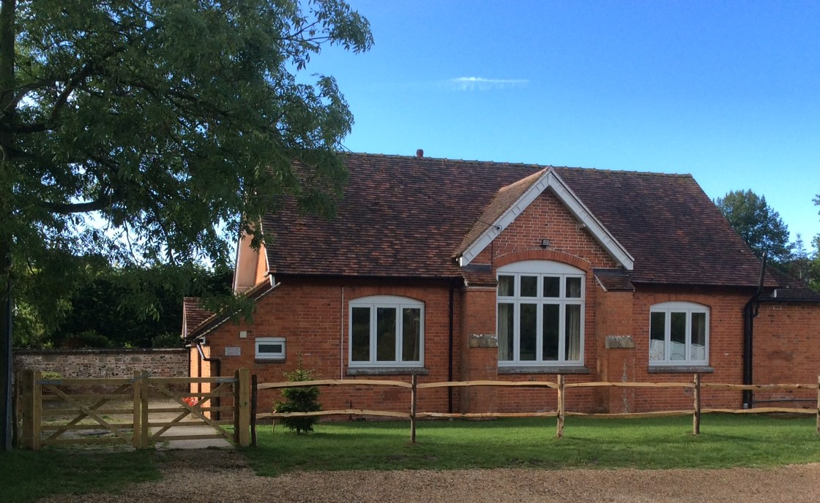
On behalf of: –
The PAROCHIAL CHURCH COUNCIL of the Ecclesiastical Parish of

St. LAWRENCE, Stratford-sub-Castle SP1 3LL

Stratford-sub-Castle Reading Room booking form

Thank you for considering our Reading Room for your event. To help you decide and then book the venue we have included information below for you to consider: -

- The booking calendar here’s the Link to check availability http://www.stratfordsubcastle.org.uk/link-to-google-bookings-calendar. Session times and prices are available by contacting our booking secretary - rrfinance@saintlawrence.org.uk
- Terms and conditions summary on page 2. (The full policy is included below on Pages 3&4)
- Hirers Risk Assessment a prepared template for the Reading Room with a number of spaces for you, if needed, to add any activities you are planning that are not covered in our document. This is a separate document that can be accessed on the Reading Room web site http://www.stratfordsubcastle.org.uk/village-hall
- The Booking Form to complete and return to secure your booking. Page 5
- Digital Projector, Sound System and Loop System – these are available and can be booked at a small additional cost. Details of use would be given after receipt of the booking form and payment

Privacy Notice

The Reading Room Management Committee uses personal data for the purposes of managing the hall, its bookings and finances, running and marketing events at the hall and its fundraising activities. Data may be retained for up to 7 years to accounts purposes and for longer where required by the hall’s insurers. Further information can be obtained from the Reading Room Management Committee.

Terms and Conditions (Summary)
Above all we want you to enjoy using our refurbished and historic Reading Room. The following summary is to remind RR hirers of their responsibilities. (The full Terms of Agreement are on pages 3 &4)
- ‘Hirer’ is the person who signs and dates the Agreement form, pays hire charges, has the specified use of hall and car park, and accepts responsibility for behaviour, safety, and building condition.
- Safety and security notices to be observed: -
- Fire escape and extinguisher facilities to be noted. Reading Room Car Park.
- Hirer to have mobile phone to notify emergency services.
- All exits to be unobstructed, with particular emphasis on Fire Exits.
- It is Hirer’s responsibility to generate and observe their own Risk Assessment for their activities.
- Kitchen is a standard domestic installation and must be used accordingly and at Hirer’s risk.
- We have to pay for recycling – please take bottles and cans away after your event.
- Car park is used at Hirer’s risk for vehicles, users, and contents.
- No smoking permitted in any part of the RR.
- Maximum number of people is 60, if you are expecting near this number we recommend you use a ticketing system to avoid disappointment.
- The Hirer must not disfigure the hall with nails, fasteners and adhesive etc., and Hirer accepts responsibility for all damage from any cause during their event.
- Entertainments where relevant (inc. music - Performing Rights Licence), and sale of alcoholic drinks must be licensed. The Owner's Public Liability Insurance will cover normal activities of non-commercial hirers (policy details available on request).
- No ball games are allowed in the hall. If something like a bouncy castle is erected it must be placed near the front of the hall to avoid potential damage to the installed projector.
- If you experience any difficulties during your hiring please ring: - Steve Mayall - 01722 411337 or Ted Uren - 01722 331766
- Safe Guarding; - The legal responsibility for Safeguarding Children and vulnerable Adults at any event taking place in a hired venue rests with the Hirer. DBS checks and certificates are Hirer’s responsibility if relevant.
- Hirer is responsible for leaving the hall in a clean and tidy state. The Booking Secretary, Mrs. Balston can put Hirer in touch with our normal cleaners if they wish. Tel. 01722 411628, Mob: 07803 132154 or hbalston@gmail.com
- Payment must be made when booking, either by BACS or cheque. Subsequently, if cancellation occurs, refunds can only be made if the Hall can be re-booked for that period.
- The door entry code will be included in the return email confirming booking. This will include details of sound and loop system if booked.

As St. Lawrence Church owns the Reading Room there are some policy guidelines: -
- Any Religious group seeking to hire the Reading Room should be affiliated to Churches Together in England.
- Any booking requests, which may compromise the mission and ministry of the church, will not be accepted.
- Decisions on such matters will rest with the Incumbent and Trustees.

Reading Room Hire Terms and Conditions

Hirers should ensure that they have read and understand the following terms under which the Reading Room is let.
This Agreement is made the day month and year set out in the Schedule between:
- "the Owner" means The Vicar, Churchwardens and PCC members from time to time of the Parish of St. Lawrence Church Stratford-sub-Castle Salisbury Wiltshire
- "the Hirer" means the person or persons and/or organisation as stated in the Schedule and their liabilities under this Agreement are joint and several.
3. It is Agreed That
a. The Owner lets and the Hirer rents for the Period (defined in the Schedule) the Reading Room ("the Hall") situated in Stratford-sub-Castle Salisbury Wiltshire for the purpose ("the Use") as defined in the Schedule Together with the non-exclusive right to park ordinary motor vehicles with others in the car park alongside the Hall (the Hall the car park and land around them or any part of them together called "the Premises").
b. The person who signs this Agreement will be considered to be the Hirer. Where a promoting organisation is named with an individual that organisation shall also be considered the Hirer and shall be jointly and severally liable with the person who signs this Agreement.
c. All charges must be paid at the time of entering into this Agreement and no hiring will be treated as booked until payment has been made and the Agreement properly signed and accepted by the person from time to time nominated as the Owner's Booking Secretary as named in the Booking Form.
d. Hiring times are as follows: -
Morning 0900-1300, Afternoon 1300-1700, Evening 1800-2300 (Sun 2230), All day 0900-2300 (Sun 2230)
e. Price for Hiring on application from Mrs. Heather Balston Tel 411628 (Booking Secretary) and must be paid when booking. Subsequently, if cancellation occurs, refunds will not be made unless Hall can be re-booked for that period.
f. A Copy of the Public Entertainment Licence is displayed in the Hall and must be read by the Hirer and the conditions met.
g. No exit from the Hall shall be blocked, no chairs or obstructions placed in corridors access ways or emergency escape routes, nor fire appliances removed or tampered with. The Hirer is notified that there is no public or other telephone in the vicinity of the Hall and is advised to have available at all times a mobile phone.
h. No excisable liquor shall be sold or supplied unless an appropriate occasional licence for the Hall has been obtained by the Hirer (from the appropriate authority) who shall produce the licence to the Booking Secretary before the commencement of the Period. (If in doubt the Hirer should refer to the Salisbury District Council Licensing Officer).
i. All the conditions attaching to the music and dancing licence for the Hall shall be duly observed, noting especially the need for the Hirer to make himself aware of the fire precautions. No naked flames are permitted. The location and method of using the fire extinguishers must be noted. The Hirer must ensure that he has made himself aware of the evacuation procedures and the method of calling the fire brigade. The Hirer must familiarise himself with the layout of the Hall knowing who will be attending the Hall. The Hirer must devise a simple evacuation plan before the start of the Period and must brief all present on the precautions. (See also Paragraphs 13-21 of the Public Entertainment Licence located in the Hall)
j. The hire of the Hall does not entitle the Hirer to use or enter the Premises at any time other than the Period unless prior arrangement has been made with the Booking Secretary.
k. The Hirer shall use the Hall solely for the purpose of the Use and for no other purpose.
l. The Hirer shall not sublet the Hall or any part of it.
m. The Hirer is responsible for all damage to the Premises and any property in or on the Premises occurring whilst in occupation or while persons are entering or leaving the Premises pursuant this Agreement however and by whomsoever caused and any such damage shall forthwith be made good at the sole expense of the Hirer
n. The Owner shall not be responsible for any loss of or damage to any property arising out of the hiring, nor for any loss damage or injury which may be incurred by or be done or happen to any person or persons using the Premises during occupation arising from any cause whatsoever or for any loss due to any breakdown of machinery failure of supply of electricity gas leakage of water fire Government restriction or act of God which may cause the Premises or any part of them to be closed or unavailable or the hiring to be interrupted or cancelled and the Hirer indemnifies the Owner against any claims which may arise out of the hiring, or which may be made by any person resorting to the Premises during the occupation of the Premises in respect of any such loss damage or injury. Hirers are warned that kitchen facilities are not to commercial standards. The kitchen is a domestic standard installation and must be used accordingly. Use of the kitchen is at Hirer's risk.
o. The right of entry to the Hall is reserved to the Owners or any agent of theirs and any police or other appropriate officer at any time during the Period.
p. The hirer is responsible for keeping good order on the Premises during the hiring and the Owners may charge the Hirer for any extra expenses they may incur for engaging the police to preserve order prior to, during or after any hiring of the Hall.
q. The Owner reserves the right to put a stop to any entertainment or meeting which in their sole view is not being properly conducted or which is not appropriate for the use of the Hall and the Owner shall not be required to give any explanation for such decision.
r. The Hall must not be used for any illegal or immoral purpose and the Hirer indemnifies the Owner against any liability arising from any such misuse
s. No bolts nails, tacks, screws, pins or other like objects including adhesives shall be driven into any part of the Premises nor shall any placards or other articles be fixed to them.
t. The Hirer at the expiration of the Period shall leave the Premises in a clean and orderly state and remove all rubbish from the kitchen to the dustbin provided. THE HALL DOES NOT HAVE RE-CYCLING FACILITIES FOR BOTTLES OR CANS and these should be removed from the premises.
u. The property of the Hirer and the Hirer's agents and other property belonging to any persons using the Hall as a result of the hiring must be removed immediately following the Period or fees will be charged for each day or part of a day until the same is removed. The Owner accepts no responsibility for any property left on the Premise.
v. No flag emblems or other decoration shall be displayed outside or on any part of the Premises or the Hall without the previous consent of the Booking Secretary.
w. No additional lights or extensions from the existing electric light fittings shall be used without the consent of the Booking Secretary.
x. No smoking is allowed within the Hall or on the Premises.
y. No ball games are allowed in the hall. If a large unit, such as a bouncy castle, is erected it must be placed at the front of the hall to avoid interfering with the installed projector

Please note:
that if the Hirer should wish to arrange to have the Premises cleaned after vacating them he should contact the Booking Secretary to be advised of the cleaners used by the Owners.
if the occupation of the Hall involves children the Hirer may need to consider having a child protection policy and may need to use the Criminal Records Bureau Disclosure Service.
The Hirer should consider taking out public liability insurance, which may give protection for financial liability which may arise and for which they may be liable.

Revised April 2018
Reading Room Management Committee
E) Reading Room Booking Form date accepted:

(for Admin. only)
Name and address of Hirer or organisation for which they are acting (printed) ……………………………………………
…………………………..............................................................................................................................................................
The period, or date(s) & time(s) required…………....…………………..………No. of people expected………(Max 60)
Phone No. …………………….. Mobile No. …….......................... Email address ……………………………………….
The Use (to which the Hall will be put) ..............................................................................................................................................
Sound System …………………… Loop System ………………… Digital Projector ………………
I have read the Terms and Conditions and understood the Risk Assessment and Safeguarding requirements, signed by the Hirer ……………………………………..
- Please complete the form above and either email to the bookings secretary, Mrs. Balston at hbalston@gmail.com or post to the address below.
- Payment is required at time of booking, either by BACS, account details below.
(Please advise payments to rrfinance@saintlawrence.org.uk in order for us to ‘confirm’ your booking)
- Or by cheque payable to: - St. Lawrence Church Stratford sub Castle PCC (RR) and returned to: The Bookings secretary (address below)
- Once the booking form and payment are received we will send you a confirmation email with the door access code.
- The WiFi code for the hall is - StLawrencePCC
Mrs Heather Balston,
2, Millers Close,
Mill Lane,
Stratford-sub-Castle,
Salisbury. SP1 3LJ

HSBC bank account St Lawrence Church Parochial Church Council (RR)

Account number: 82071398

Sort code: 40-40-14

Thank you for booking with us, we hope you enjoy our Reading Room and please come again!

