Stratford sub Castle Sunday Café Review - August 2019
August’s Sunday Café on 11th August was the busiest of the year so far. Although the weather had cooled down considerably and there was even the threat of thundery showers, the Reading Room was packed with both locals and folk from further afield enjoying the tea, coffee and cakes on offer. With their usual efficiency, the café team kept it all running smoothly with trays quietly recycled and the washing up producing clean cups and plates seamlessly to cope with an unusually high demand.
There was as usual a wonderful selection of cakes on offer – several people even came prepared to take slices of cake home to enjoy later, as well as purchasing some of the local produce from allotments and gardens in the village.
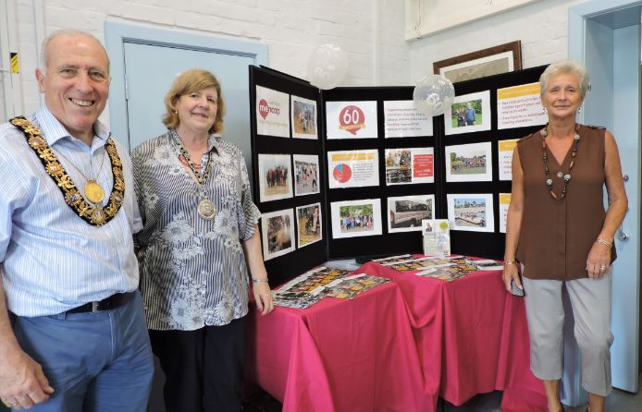
Our local resident Mayor and Mayoress, John and Carrie Walsh, also came along with lots of information about South Wilts Mencap, our chosen charity for the donation of proceeds and of course John’s chosen charity for his time in office.
Mencap is a charity dear to John’s heart, and he has been involved with it for more than 20 years. During this time he has been at the forefront of raising the charity’s profile and increasing the provision of services for people with learning disabilities. In particular, he has been instrumental in helping to address the gap in provision for younger people. The charity’s work is vital in improving the lives of those affected by learning disability and their carers and families, and a significant proportion of their funding is through their shop in Catherine Street, which always welcomes new volunteers. If you would like to help fund their valuable work please also consider donating through their website ) or remember the charity in your will.
In total the café raised an astonishing £410.60. With an additional donation of £5 and a donation to cover the Reading Room rental (thank you!) we were able to donate £210.30 to South Wilts Mencap and another £205.30 towards our community fund.
Our final Summer Café will take place on September 8th. After the somewhat gloomy days of August, I hope the weather will be kind and see the whole village come together for a rousing finale!
Clare Ereira

