Christmas Café 2018 - by Clare Ereira
The last pop-up café of the year took place on Saturday 8th December. Our Christmas café is always a wonderfully festive event, and this one was no exception. Although the weather outside was cold and a bit damp, the reading room was warm and welcoming with plenty of twinkly lights and decorations to put us all in the mood for Christmas.
As always, Barbara and a team of volunteers ensured that the whole event ran like clockwork, with a range of delicious soups, cheeses and festive baked goods on offer as well as mulled wine which was delightfully warming on such a cold day. The produce table was filled with a selection of chutneys and jams as well as some Christmassy food items, crafts and oddments, while the raffle table was heaped with generously donated prizes.
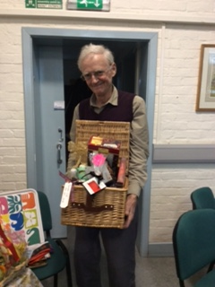
Ted Uren was the proud winner of the first prize – a magnificent hamper of goodies.
The cheerful buzz of activity was matched by the raising of a grand total of £960. This included some extra sales from the produce table, which was left out for the concert in the evening and the next day after the church service. Thank you to Karen who kindly manned it for these times.
All of the money raised has been passed on to our two chosen charities, Salisbury Trust for the Homeless and Salisbury Women’s Refuge, thanks to a generous donation to cover the rent of the Reading Room for the day. These are both hugely deserving charities which provide help and support for people who are particularly vulnerable at this time of the year.
Many thanks to all the volunteers who slaved away cheerfully on the day, to everyone who donated raffle prizes, produce and foodstuffs, and especially to Barbara whose unfailing efficiency and hard work made for such impressive success.

