Cantemus Concert Dec 2018: Angelic voices return to St. Lawrence Church
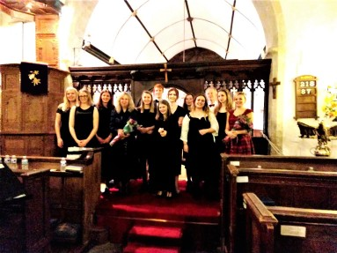
After a 2 year break and with a new line up of established and new members, The Friends welcomed back local girls’ ensemble Cantemus for a pre-Christmas concert. All the girls study with husband and wife team Meinir Williams and James Ottaway, both acclaimed and experienced professional singers. Meinir is the Musical Director and conductor. James is the arranger and accompanist.
James once again arranged the programme into four distinct sections: Sacred, Folk, Popular and Christmas, interspersed with two excellent soloists. There was a blend of Cantemus ‘standards’ and new songs arranged by James so that each voice could contribute its unique quality to the group. As one audience member commented: “The balance of the programme was perfect and showed off the breadth of what the girls could do.”
The evening started with a Cantemus standard, Evans’ ‘Be still for the presence of the Lord’, which produced this response from an audience member: “From the opening I knew we were in for another treat.” This was followed by a selection of sacred pieces and traditional folk songs, separated by three lovely pieces from Benedict Parker, a talented young tenor student of James. Ensemble members Oli and Lucy treated us to a delightful duet of ‘Panis Angelicus’ and my daughter Katie sang a beautiful solo of ‘Ave Maria’. This produced this comment from one of the audience: “The duet and Katie's Ave Maria were stunning, showing how far these girls have come since we first heard them.”
The interval had the audience chatting enthusiastically about the quality of the performances. The second half started with four well-known songs from the 60s – 90s, followed by four lovely pieces from mezzo soprano Cassandra Dalby, an ex Cantemus member, newly graduated from Trinity Laban Conservatoire of Music and Dance in London, who again gave a magnificent performance. Cantemus finished the programme with some seasonal songs to put us all in the Christmas spirit, closing with a glorious rendition of their signature piece, wonderful ‘Mirabile Dictu’.
Clare and I have watched the group develop over the past few years and acknowledge that we might be somewhat biased given Katie is a member so it is fantastic to see their talents recognised by others. We were able to share a very proud moment with everyone when Meinir publicly congratulated Katie in being offered a place at The Royal Welsh College of Music and Drama.
I had many more positive comments from those in the audience, including the following:
“Another triumph. What a wonderful concert. The girls just get better & better.”
“I thought that Cantemus was absolutely superb, even better than ever, and the two soloists were outstanding.”
“We thoroughly enjoyed the concert and were very impressed, yet again, by this superb group of talented and gracious young women.”
“I very much enjoyed the concert. The girls singing together made a lovely sound.”
“We were impressed by the continued improvement in the performances, both solo and choir. Great choice of music and brilliant accompaniment. An evening to remember.”
“This is not a genre of music that I naturally focus on, but I thoroughly enjoyed the concert. A delightful evening and I am very pleased that I made the effort to attend.”
“I certainly feel privileged to have been present at such a glorious feast of music.”
“Thank you so much for arranging the concert - hopefully to be repeated.”
“An enormous success - everyone is saying so.”
Many thanks to all who gave feedback on the concert. Apologies that I have been unable to include all the comments received, but I have passed them all on to Meinir and James.
Terry Ereira

