Stratford sub Castle Garden Club
Presentation, AGM and Quiz Night. 27th Jun 2019
A busy evening started with a very happy event – the presentation of a cheque for £500 to Alabaré Old Sarum Development (Garden) Centre. The cheque was received by Markus Fanti who is the person in charge there. Within five minutes, we all realised that Markus was full of enthusiasm and his clients at the Centre are so fortunate to have him. The money will go towards improving facilities for wheelchair clients. This includes the development of raised beds and improved pathways so that they can have more access to horticultural activities, gaining both skills and enjoyment from doing so. In May 2020, the Garden Club is going to visit the Centre so that we learn more about it and have the opportunity to purchase plants that are produced there. All of this has been arranged by Garden Club Member and Secretary, Judith Meyrick who gives two days each week, as a volunteer, to Alabaré.
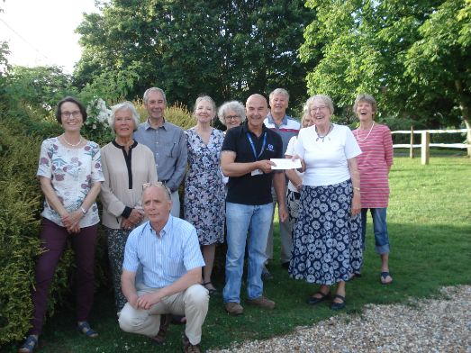
Following the presentation, much laughter accompanied a group photograph of Markus and all of our Committee, who worked so hard to raise this money at the Open Gardens event.
The AGM followed swiftly with small gifts and massive thanks for the huge amount of work done by retiring Committee Members: Elizabeth Winders, Jeff Long, Judy Villiers and Steve Mayall. They will be much missed. There was a presentation, too, for the retiring Chairman, Dorothy Richards, who was delighted that the new Chairman is to be Barry Goldsmith. Dorothy will remain as a Committee member. Jo Harrison was thanked for her work as Programme Secretary, a task that she had undertaken for almost five years. She will remain on the committee and Angelina Turrall will take on the Programme Secretary role.
The evening continued with a superb quiz organised by Steve Mayall. Questions covered garden history, garden celebrities, fruit trees, flower-arranging and many other garden related topics. It was most enjoyable and there were lovely prizes too.
The usual refreshments and much conversation brought the meeting and the Garden Club Year to a close. Our full and exciting programme for the season 2019-2020 will be published soon and our first talk in the new season is on Thursday, 26th September. Don’t miss it – it is an intriguing topic.
Dorothy Richards

