Stratford sub Castle Guild 8 September 2021 ‘Salisbury Museum Developments’ Adrian Green
We are back! The Guild held its first meeting in the Reading Room since March 2020. A full complement of socially distanced, Covid-aware Guild members listened to an entertaining, information-packed presentation from Adrian Green, Salisbury Museum Director.
Since his appointment in 2007 Adrian has been working towards bringing the museum up to date, increasing visitor numbers, fundraising and reaching out to the local community. The first phase of his plan took a Heritage Lottery Fund grant of £1.8M in June 2012 of a total cost of £2.4M and 6 years to bring to fruition when the Wessex Gallery of Archaeology opened in July 2014. Visitor numbers went up, local community engagement increased and planning was underway for the next phase of development. Then in March 2018 came the Novochok poisoning, followed by the Coronavirus pandemic. Nevertheless, plans continued and the latest project: “Past Forward: Salisbury Museum for Future Generations” continues the development at the museum.
Proposed future developments (all drawings by Metaphor Design) Devenish Bradshaw Salisbury Gallery – named to commemorate a generous donation from the Bradshaw family in Canada, descendants of the Devenish family. There will be 3 galleries telling Salisbury’s story from 1220 to the present.
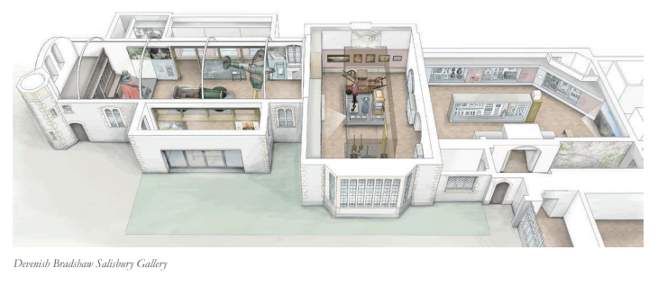
- Mediaeval Room (13–15C), with the Drainage collection having pride of place. Highlights: Scandinavian Ivory Chess piece, ‘Sneezing’ Clarendon Head, Limoge enamelled cross, 15C Pilgrim Badge from Mont St Michel
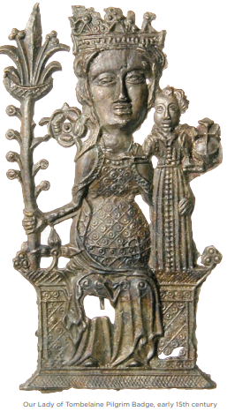
- Transition Gallery – Tudor, Stuart and Georgian Room (15–19C). Highlights: Sedan Chair, Tudor finger ring, Pair of pistols, Constable drawing of St Ann’s Gate, Beaton’s painting of Ashcombe.
- Victoria and Modern Room (19–21C). Highlights: Salisbury Giant, Scout car, Devenish/Bradshaw family portraits, Novochok and Coronavirus display.
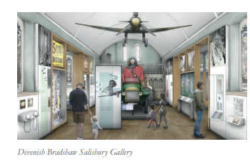
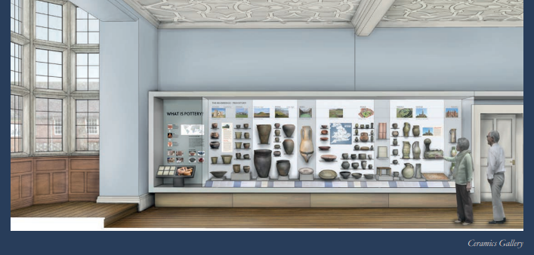
Ceramics Gallery – a refurbished gallery, with its 17th Century ceiling restored. Using the museum’s pottery collection to tell a ‘potted history’ of ceramics in Britain.
Natural History Gallery – the museum’s natural history collection, currently in long-term storage, will be displayed to explore issues of bio-diversity and climate change.
Learning Space – a new space for learning and activities. Event Space – a new venue for lectures, courses and community meetings. Restoration – work to conserve the fabric of the building. Also planned is an enhanced Activity programme, to embed the museum in the community. Adrian stressed he sees the museum is for everyone, particularly for the people of the local community. He emphasised the use of:
- Local People Local Trades Local Flora/Fauna Local Artefacts
- Local Events Local Environment Local Fossils Local News Local projects
Concluding his talk Adrian gave some key dates in the project: June 2021 Final application to the National Lottery Heritage Fund (NLHF), including confirmation all match funding can be raised Autumn 2021 NLHF final decision Late 2022 Work starts on site; Early 2024 New galleries open
Monies: The total cost of Past Forward is £4.4M NLHF grant requested £3.2M Donations and pledges received to date £665K Remainder to be raised £535K Gift Bowl collection raised £110 to be donated to the project funds.
To see a similar talk by Adrian use the following link: http://www.salisburymuseum.org.uk/about-us/museum-masterplan
Museum donating link for those who want to contribute: http://www.salisburymuseum.org.uk/support-us/donations

Terry Ereira

