Stratford sub Castle Garden Club 31st January 2019
There are no Gardening Mistakes – Only Experiments.
Jeff Long and Steve Mayall
This was a ‘first’ for me as I had to cancel the meeting because of imminent snowfall – but not to worry as this very entertaining talk is saved for a future meeting, possibly the AGM if both speakers can be there.
At our next meeting, on 28th February, the Speaker is Rebecca Twigg. Rebecca is passionate about wildlife and has made Salisbury the first place in the country to have an educational ‘Bee Trail’. Her other local major project is ‘The Secret Garden’. This is a Community Garden in St. Clements Church Yard and the first Open Day this year is on Sunday, 5th May, 12 noon-4.00pm. Do come along to hear her talk, 7.15 for 7.30pm in the Reading Room, SP1 3LL. New members and visitors are most welcome.
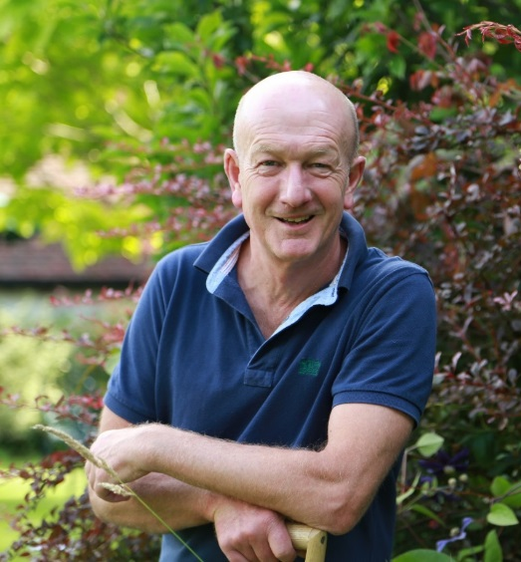
Andy McIndoe will be the speaker on 28th March and he will telling us what goes on ‘Behind the Scenes at Chelsea’. This is not about show gardens or judging but about his time in charge of the Hillier display in the big marquee at the Chelsea Flower Show. He won twenty five consecutive Gold Medals – an amazing achievement and a huge responsibility. Andy is such an entertaining speaker so there will be plenty of laughter. Many of us feel we know him well as he showed us around his garden in the summer of 2017 and the Club made a previous visit some years before that. He has written several books about plants and garden design – all very readable.
Tickets for this event are £10.00 or £8.00 for Garden Club members and are available from me, at the meeting in February or by phone on 01722 321431. Do come to the Reading Room, opposite St. Lawrence Church, 7.15 for 7.30pm where there is good company and a free car park. Refreshments are included.
Dorothy Richards

